Lab No | : | 05
Name of the Lab | : | Connecting a database(MYSQL) with Linux
ID | : | IT-17035
Objective | : | To know how to install database in Linux and perform various operation via connecting to it .

1.Install mysql on ubuntu :

To word with database we first need to install the database in our system using the command below we can install mysql-server .
sudo apt-get update sudo apt-get install mysql-server

Now that we are done with setups we can start out experimenting with database system by logging in .

2.Log into MySQL by Linux:

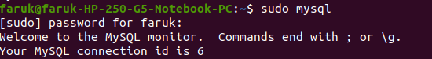
To get the list of data Databases type show Databases .

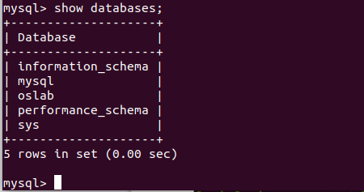

We need to select a database first to do so we use the keyword select ‘DatabaseName’

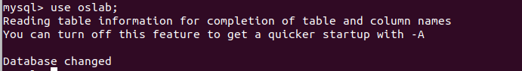
3.Create database table :

Now to create a table we use the syntax create table ‘TableName’ Values(val1_name <data_type> , val2_name <data_type>…….);

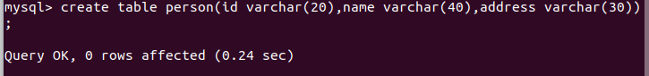
4.Insert data into table :

Now to insert values to the table we use the keyword
Insert into ‘TableName’ Values( val1 , val2…);

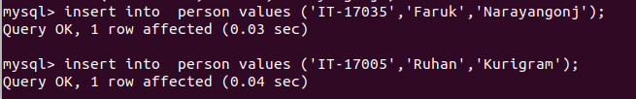
5 . Describe table :

Now to see whats in the table we use select * from ‘TableName’

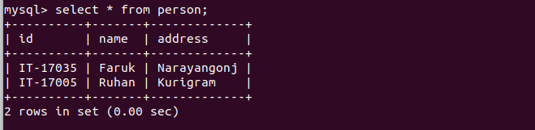
6. Alter table :
Alter table tablename add columnname datatype(40) ;

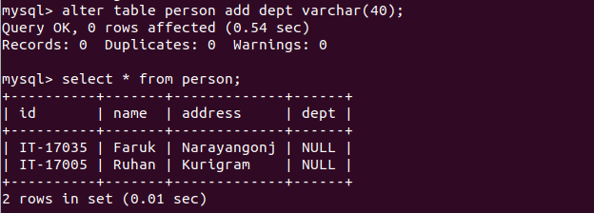
7.Modify table :
alter table tablename modify column column_name datatype ;
alter table tablename change oldcolumnname newcolumnname datatype(size);

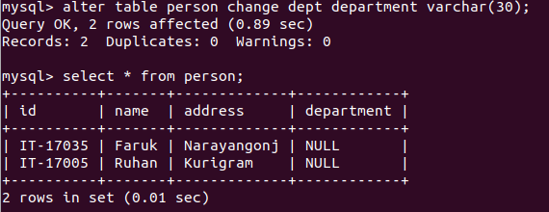
8 . Drop data from table :
delete data from table.

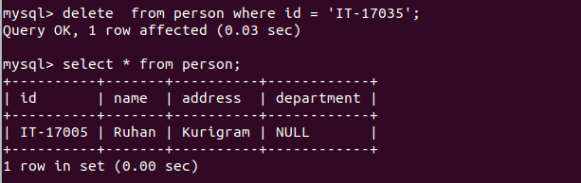

9.Update data of table :
update tablename set columnname =’’ where primary_key = ‘’;

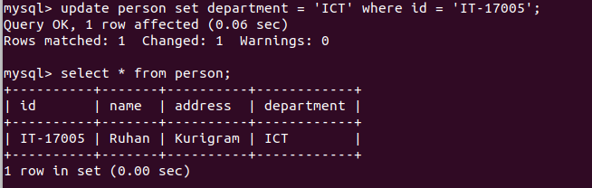
Now if we want to exit the database then we just have to type “exit “

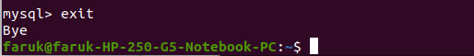

conclusion :

In this lab we learnt how to install database in Linux bases operating systems . Using database is a convenient way of saving data in both research and technical fields , so it will be of great help in near future .

